SNOWFLAKE PERFORMANCE MANAGEMENT
MICRO PARTITIONS
What are micro partitions?
Table data is stored in files of size 50-500 MB. These are the contiguous storage units
The logical structure of the table is stored into physical structure in micro partitions as per clustering key which snowflake maintains
Micro partitions are small files of size 50 – 500 MB
Here is the example as per the snowflake documentation
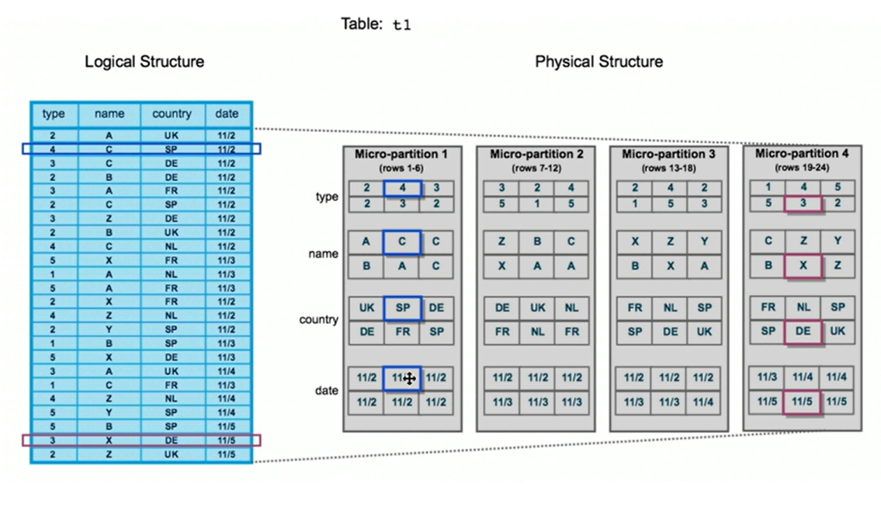

Once if u add a clustering key, it will take data from logical structure ‘date’ and ‘type’ and it will sorts the data and new version of micro partitions are created in the order of sorted data as shown
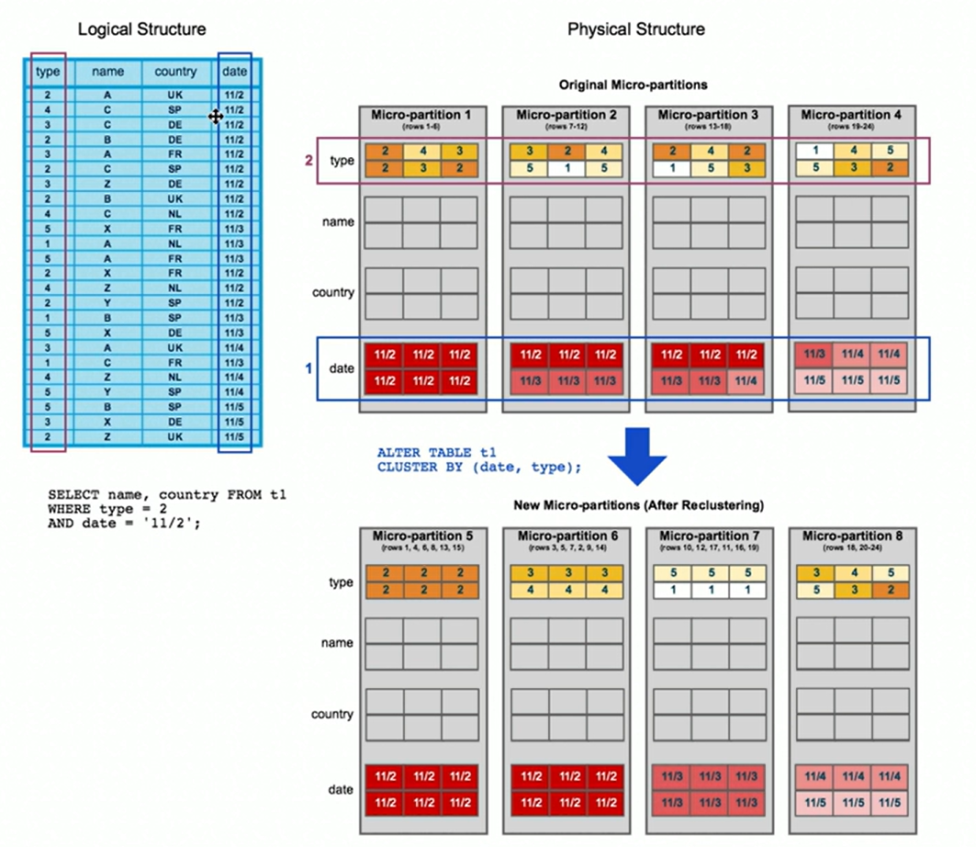
Micro partitions can’t be modified once created while inserting/deleting/updating as they are immutable
If you insert the data, the new micro partitions gets created
If you update the data, new micro partitions gets created with new updated data but it has to scan and check the previous version of micro partition has that same data
If you delete any row, a new micro partition gets created with same data but that particular row will not be there in new micro partition
Query pruning:
In simple words, if you don’t have a clustering key and run a query, all the partitions will be scanned but when if you add a clustering key, micro partitions scan will be limited based on the conditions that give in your query
Take any example and add clustering key to the table and run a query on it
Here is the image
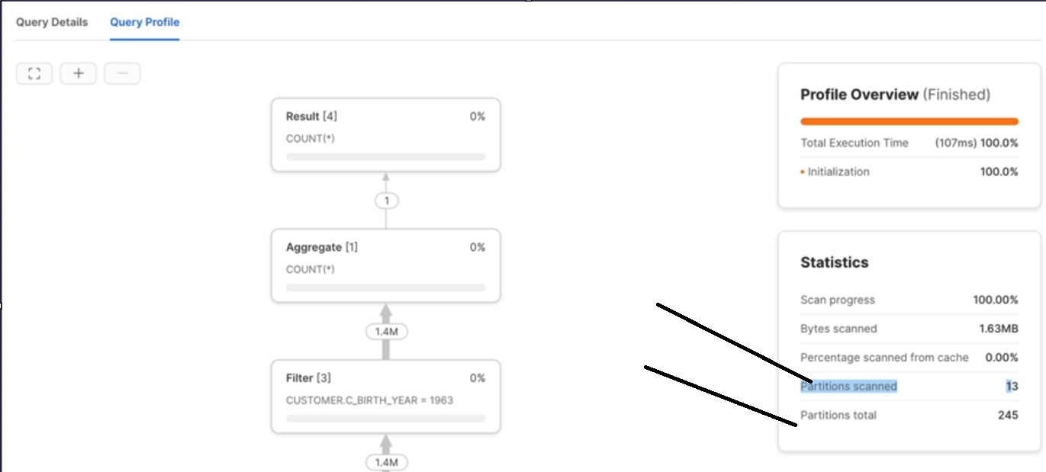
You will get clarity of how will it selects partitions scanned in below theory.

What is overlapping micro partitions and overlap depth??
In the below image with different cases, overlapping of data in micro partition happens and that’s the reason the terms overlapping micro-partitions and overlap depth (number of overlapping micro partitions) comes into picture.
Let’s take case2 in below image, if you want to get data in between k to z, it has to scan 3 overlapping micro partitions which makes your execution faster rather than scanning all the micro partitions

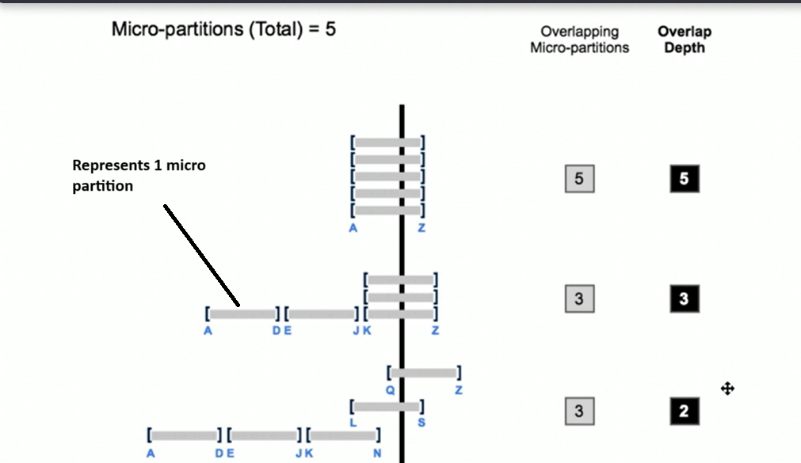

In previous post snowflake_11 as shown
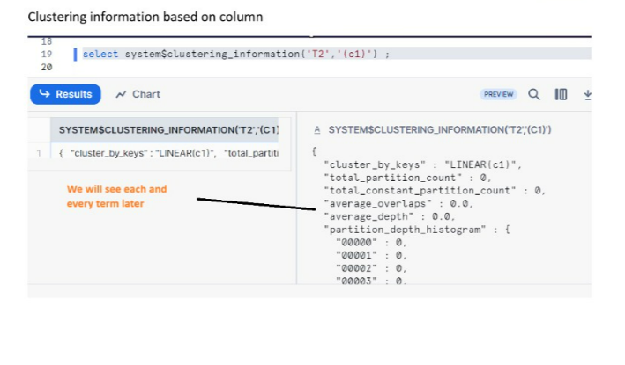
Let’s discuss each and every term
Cluster_by_keys – These are the clustering keys that you need to create as per the requirement
Total_partition_count – total number of partitions it scans
Average_overlaps – for each micro partition, what is the avg overlap
Average_depth -- for each micro partition, what is the avg overlapping depth
Partition_depth_histogram – it’s like how many micro partitions have a depth of 0, 1,2,3,4, etc.

Why is clustering needed??
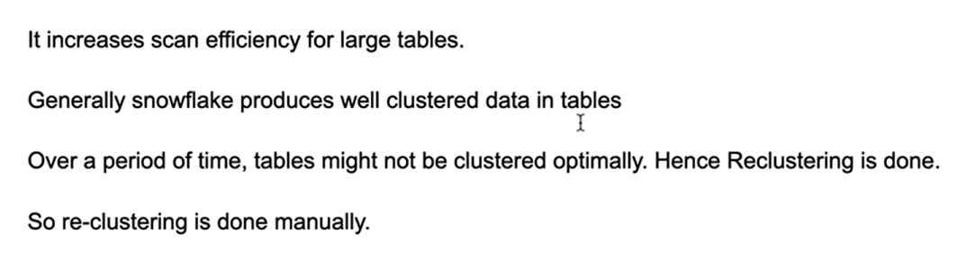

How to check if clustering is needed??
If performance degrades for large (multi TB) tables. Clustering is an option but comes with a cost
Which columns should be used as cluster keys??
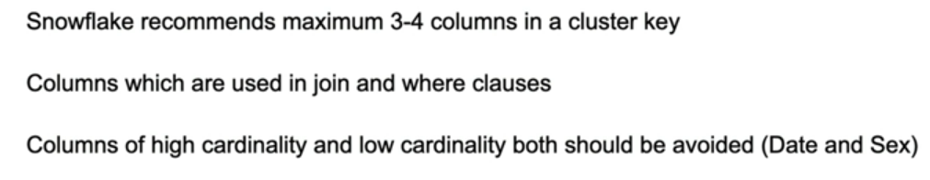
What are clustering guidelines and best practices?
